Requirement Analysis
Technology Stack (Architecture & Stack)
Date | 8 October 2026
Student Name | OviyaShree
Project Name | Metro Ticket Generating System in ServiceNow
Maximum Marks

Technical Architecture
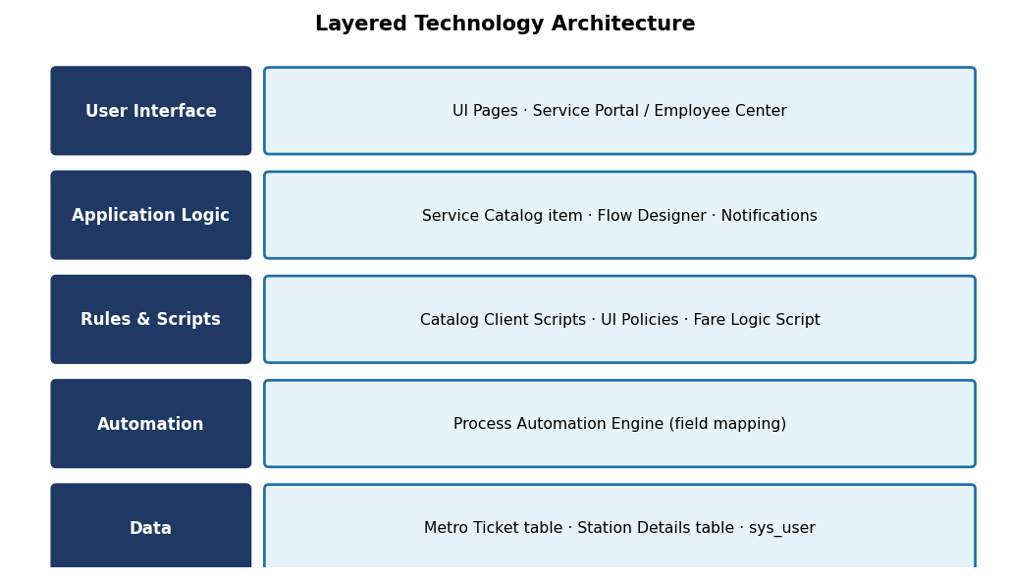
Figure 1: Layered technology architecture for the ServiceNow solution.
S.No. | Component | Description | Technology
1 | User Interface | Passenger-facing booking pages and digital ticket view. | UI Pages / Service Portal
2 | Application Logic | Ticket booking and automated ticket generation. | Service Catalog / Flow Designer
3 | Rules | Field validation, mandatory fields and auto-populate logic. | Catalog Client Scripts / UI Policies
4 | Fare Logic | Automatic fare calculation. | Fare Logic Script (Script Include)
5 | QR Code | Digital ticket QR code generation. | QR Code Integration
6 | Automation | Auto mapping of fields and values entered by users. | Process Automation Engine
7 | Communication | Booking confirmation to passengers. | Notifications
8 | Data | Ticket, station and user records. | Metro Ticket table / Station Details / sys_user

